**Advanced Java Programming [IT404]**

**Open-ended Project**

Submitted to Dr Akansha Singh

Ramanuj Sharma A2305218670

Simran Gogia A2305218675

Utkarsh A2305218717

6CSE12

**Project Title:** E-Commerce website using Servlets and JSP

**Tech Stack:** Java Servlets, MySQL, JSP, Bootstrap

**Theory:**

The project, titled *store.xyz*, is a mockup for an E-Commerce application built on Java and MySQL. We have used Eclipse as the IDE for Development.

Our project is on an E-Commerce website using Servlets and JSP. Apart from these, we have used Bootstrap for design and some custom CSS. On the main screen of our application, *store.xyz*, users can see all the products that are available in the catalogue. These are not statically typed, and are fetched from the SQL database using Servlet and rendered using iterative loops in JSP, which is then embedded in the main HTML page.

**Source Code:** The source code in its entirety has been uploaded on GitHub, which we also used for version control during the development stage. Some key source files are shown here.

**GitHub Repository -** <https://github.com/skhiearth/E-Commerce-Java-Servlets>

Project File Structure:

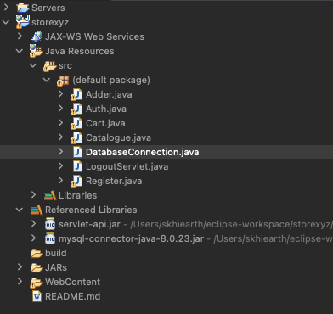

*DatabaseConnection.java (*[*https://github.com/skhiearth/E-Commerce-Java-Servlets/blob/main/src/DatabaseConnection.java*](https://github.com/skhiearth/E-Commerce-Java-Servlets/blob/main/src/DatabaseConnection.java)*)*

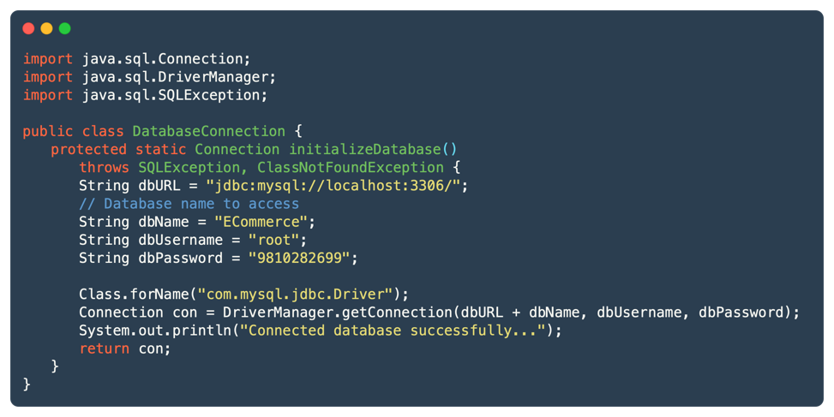

*Catalogue.java (*[*https://github.com/skhiearth/E-Commerce-Java-Servlets/blob/main/src/Catalogue.java*](https://github.com/skhiearth/E-Commerce-Java-Servlets/blob/main/src/Catalogue.java)*)*

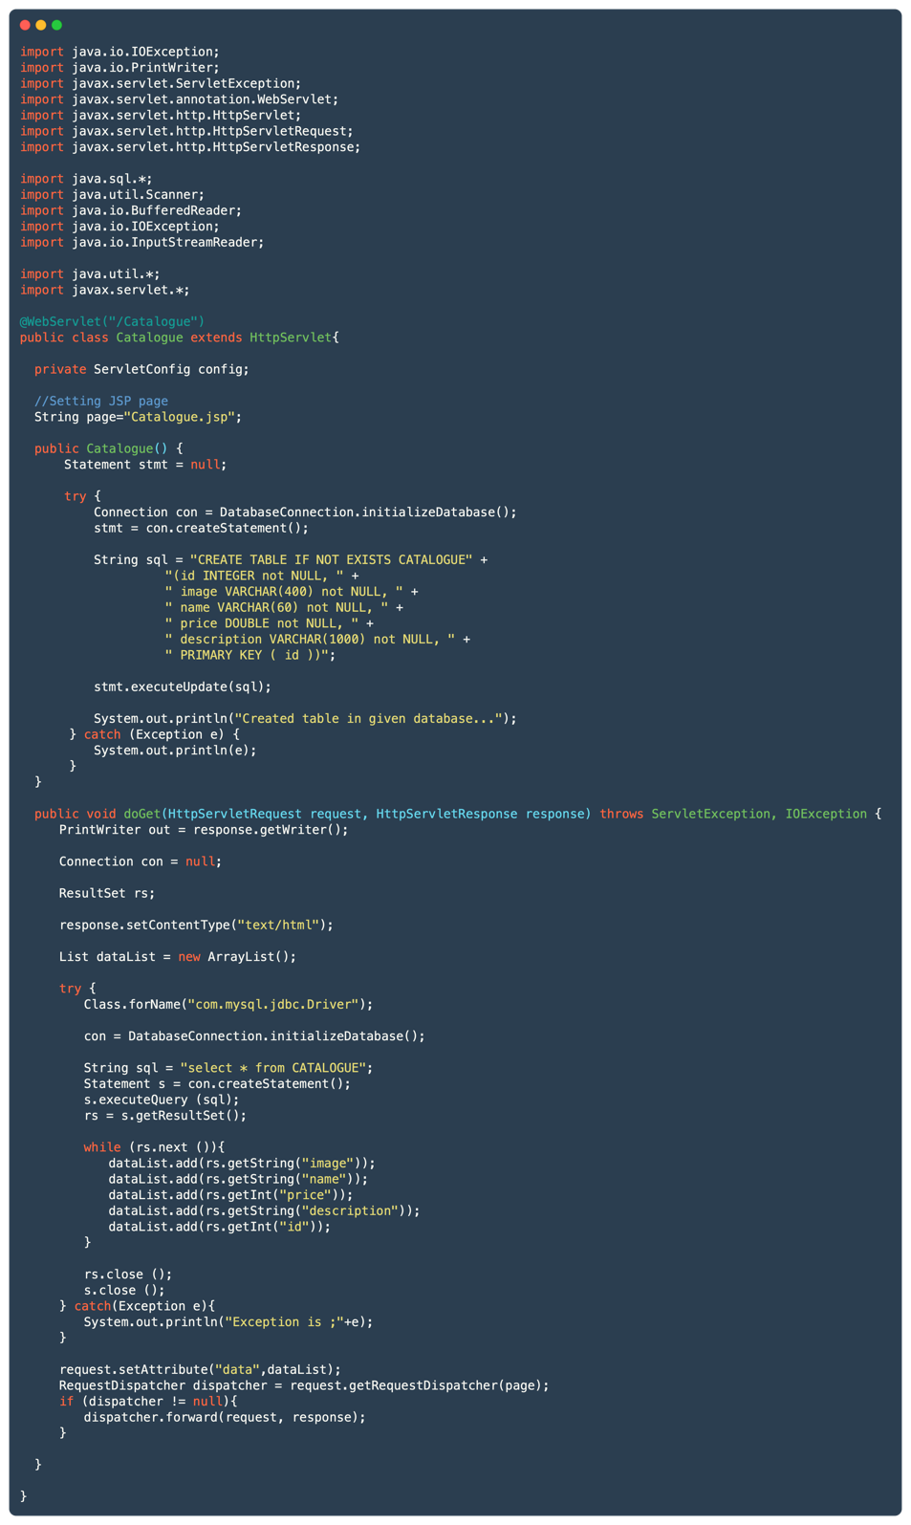

*Auth.java (*[*https://github.com/skhiearth/E-Commerce-Java-Servlets/blob/main/src/Auth.java*](https://github.com/skhiearth/E-Commerce-Java-Servlets/blob/main/src/Auth.java)*)*

*Cart.java (*[*https://github.com/skhiearth/E-Commerce-Java-Servlets/blob/main/src/Cart.java*](https://github.com/skhiearth/E-Commerce-Java-Servlets/blob/main/src/Cart.java)*)*

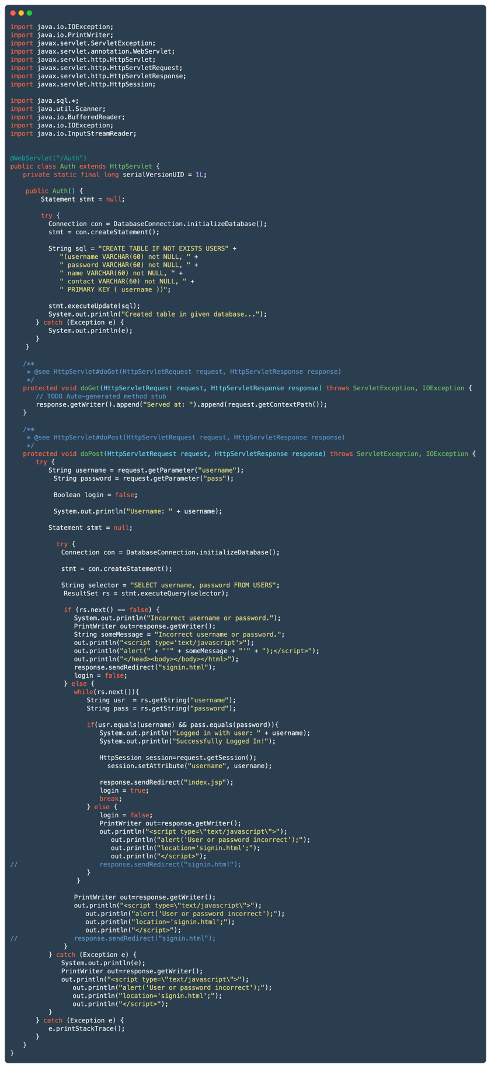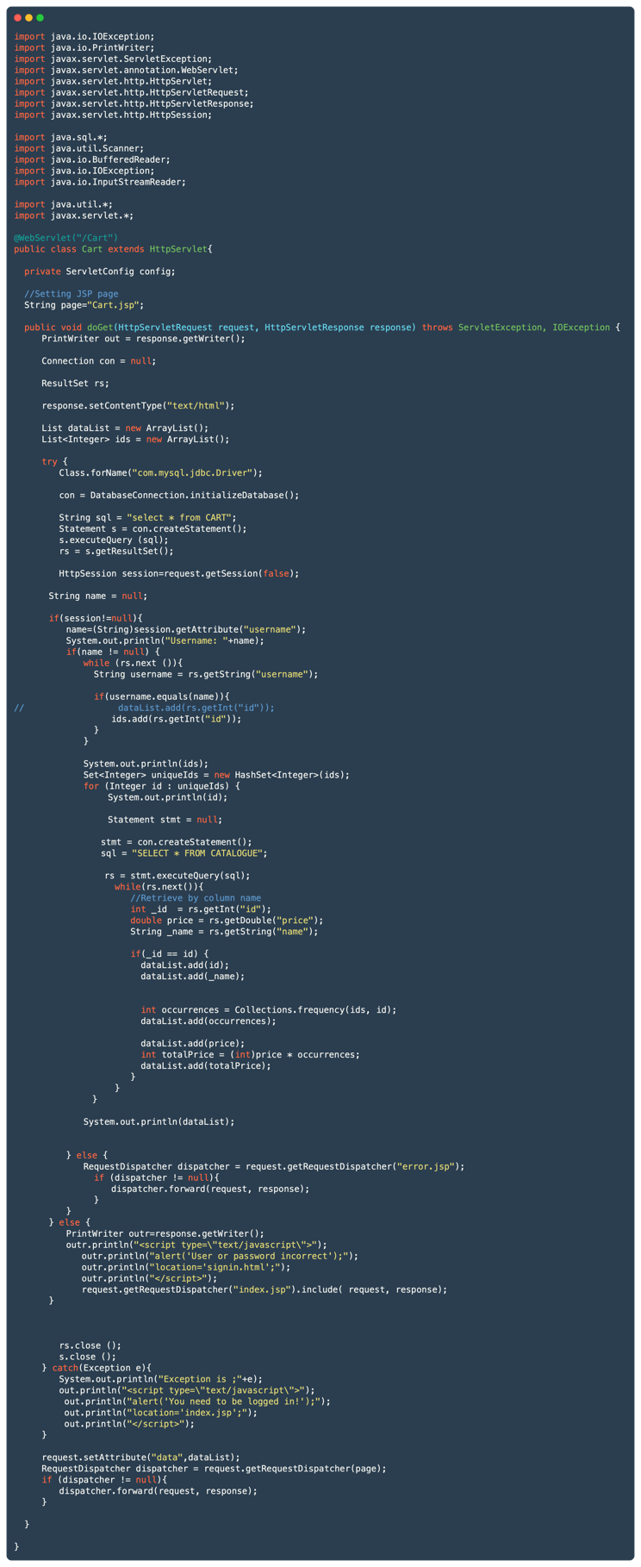

*LogoutServlet.java (*[*https://github.com/skhiearth/E-Commerce-Java-Servlets/blob/main/src/LogoutServlet.java*](https://github.com/skhiearth/E-Commerce-Java-Servlets/blob/main/src/LogoutServlet.java)*)*

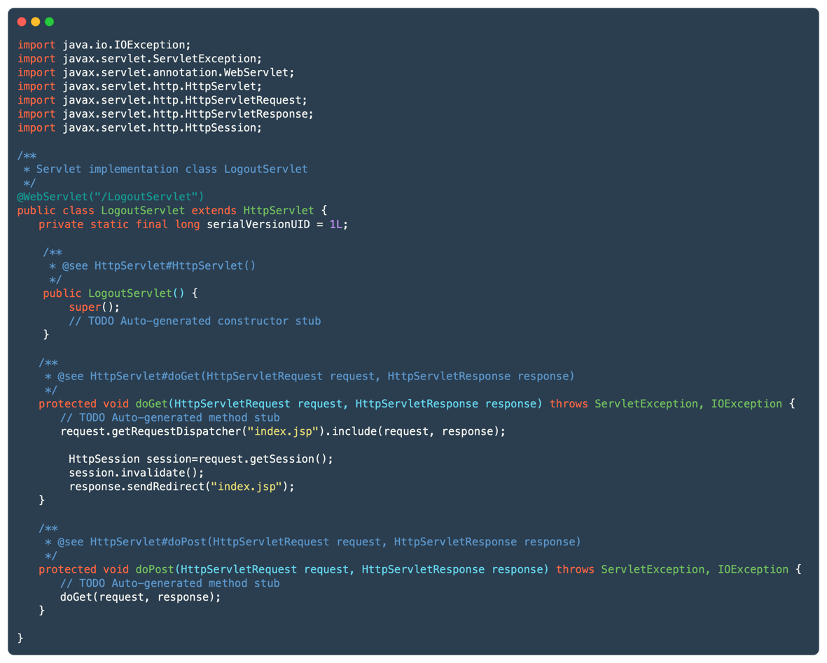

*index.jsp (*[*https://github.com/skhiearth/E-Commerce-Java-Servlets/blob/main/WebContent/index.jsp*](https://github.com/skhiearth/E-Commerce-Java-Servlets/blob/main/WebContent/index.jsp)*)*

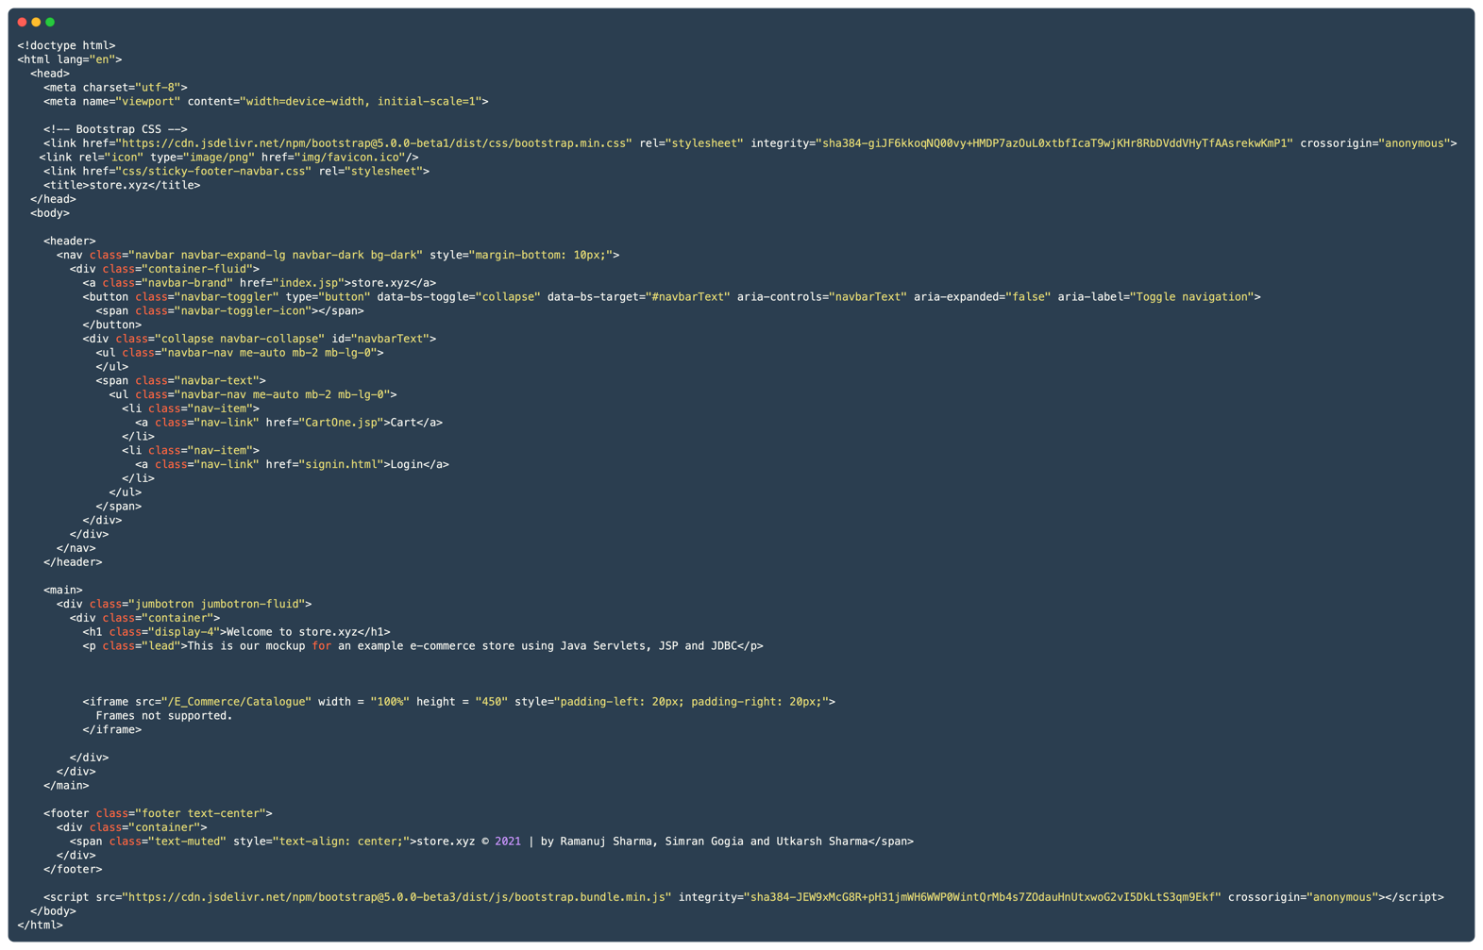

Full Source code on GitHub (<https://github.com/skhiearth/E-Commerce-Java-Servlets>)

**Outputs:**

http://localhost:8080/E_Commerce/

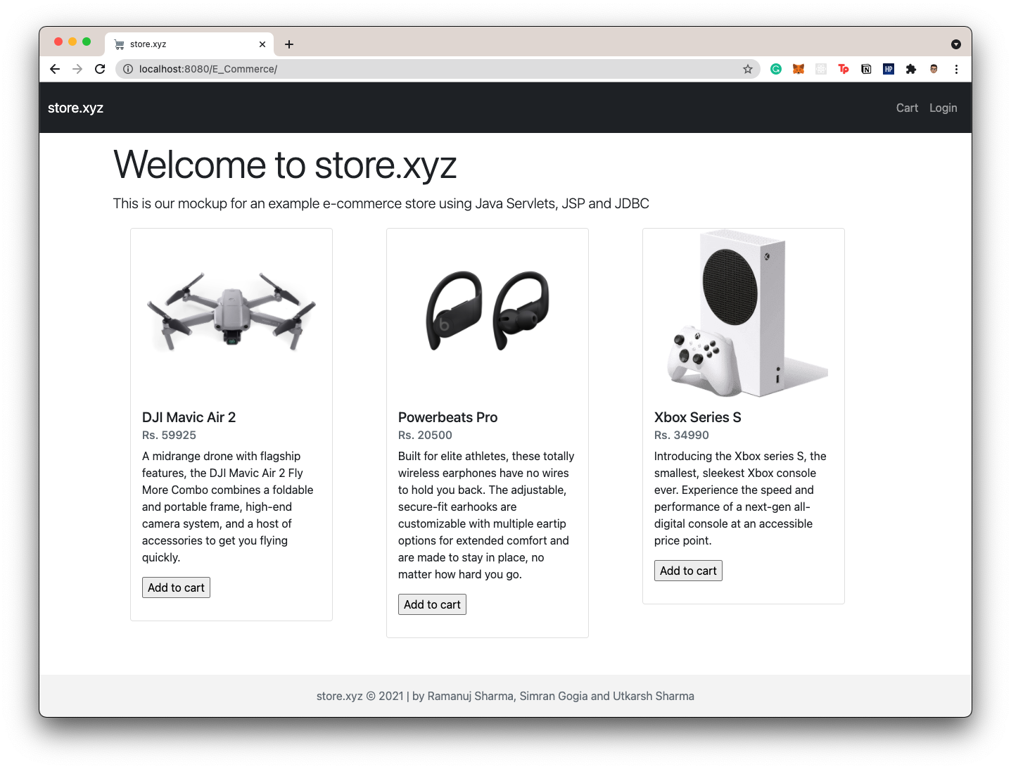

http://localhost:8080/E_Commerce/signin.html

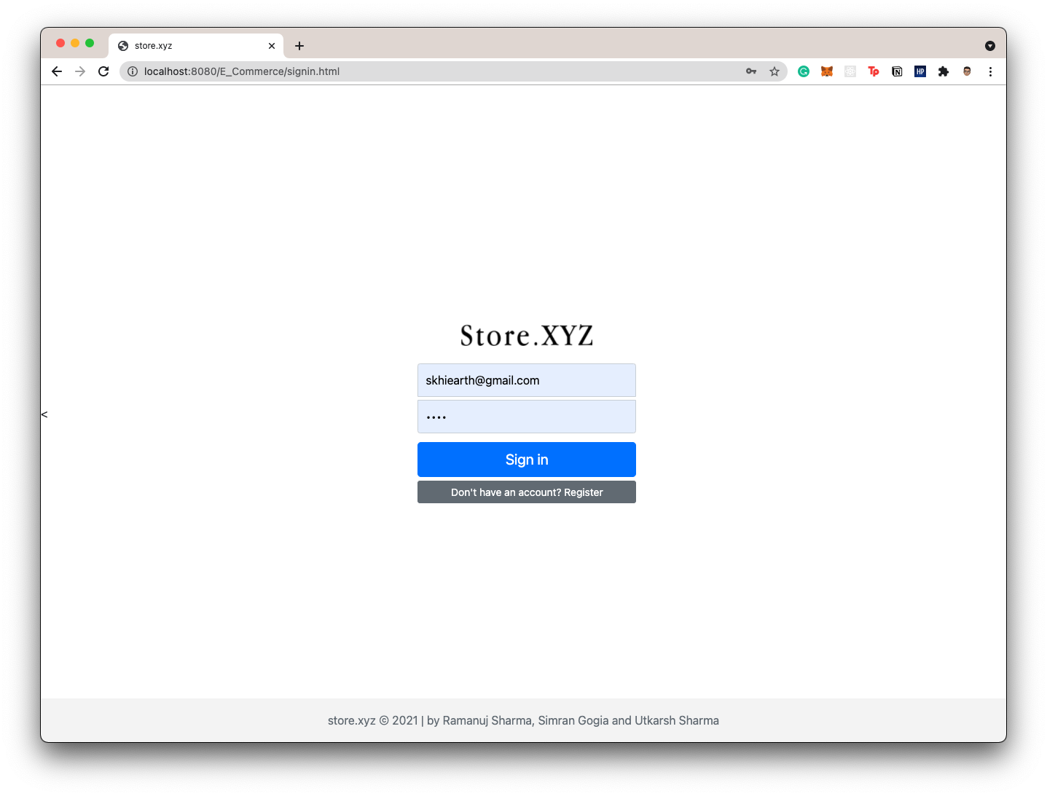

http://localhost:8080/E_Commerce/register.html

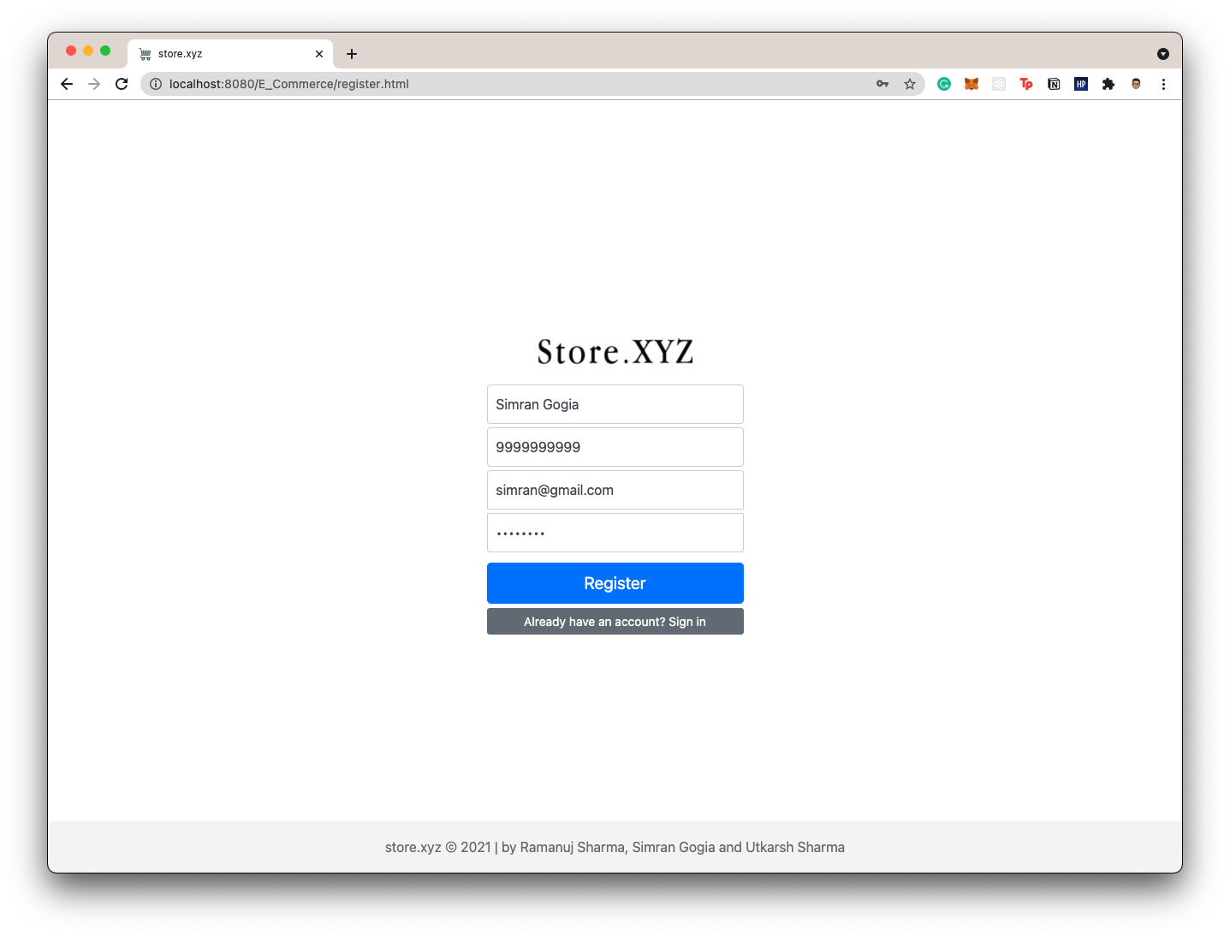

http://localhost:8080/E_Commerce/CartOne.jsp

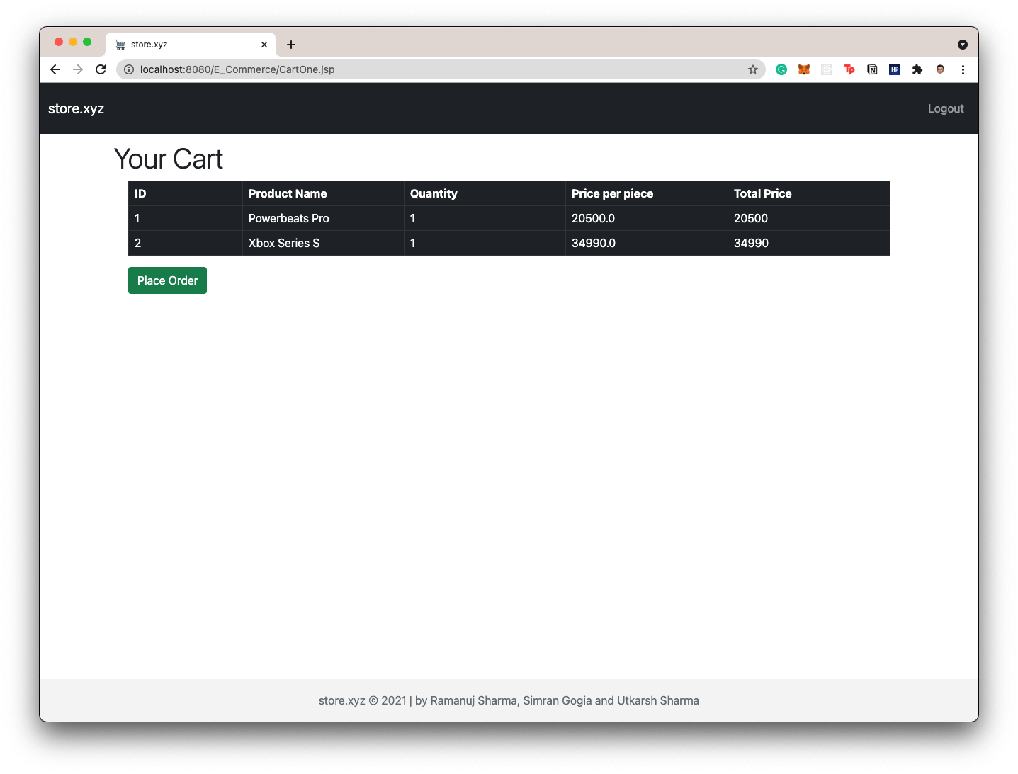

**Database Snapshots:**

*ECOMMERCE Database*

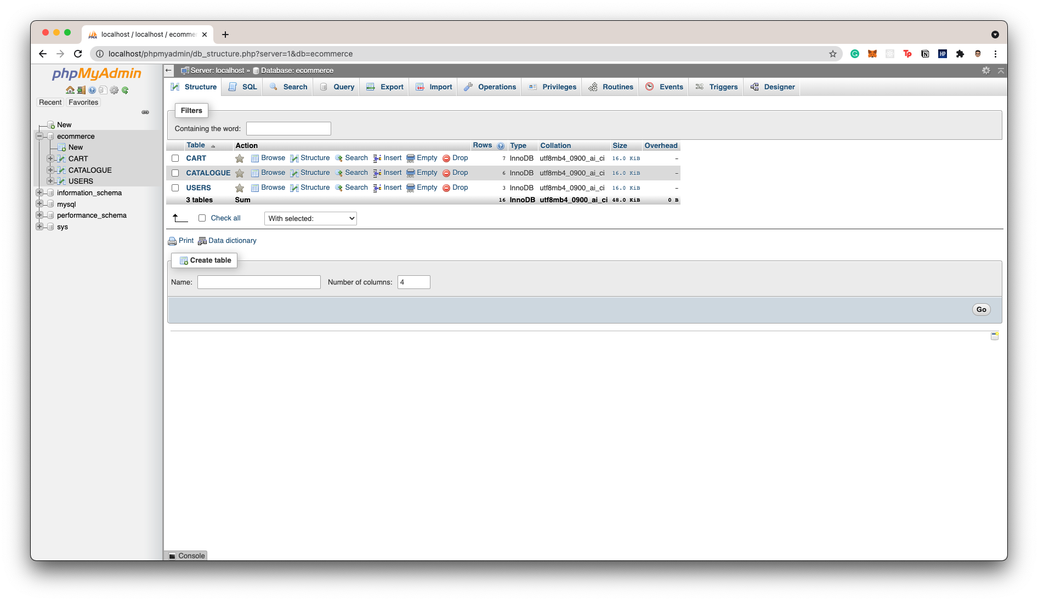

*CATALOGUE Table*

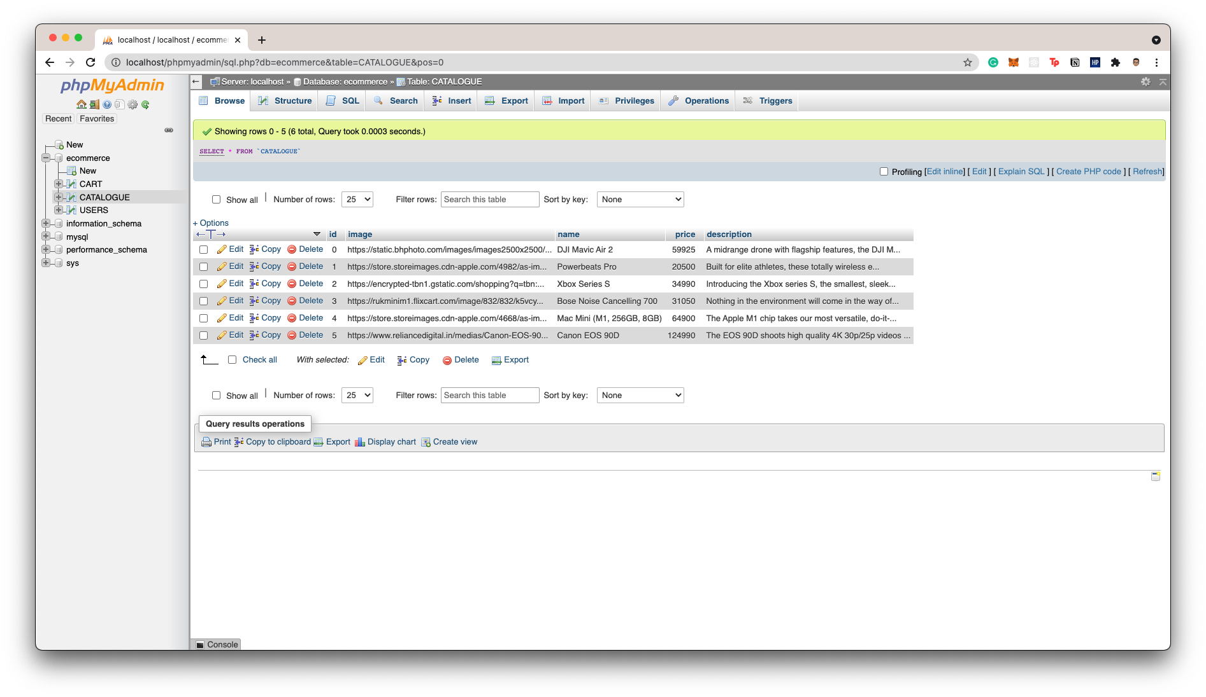

*USERS Table*

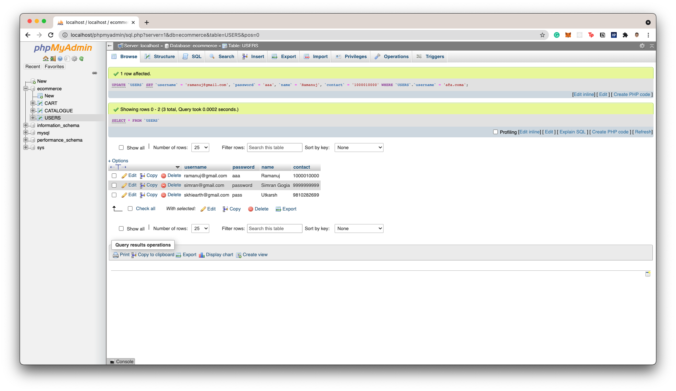

*CART Table*

